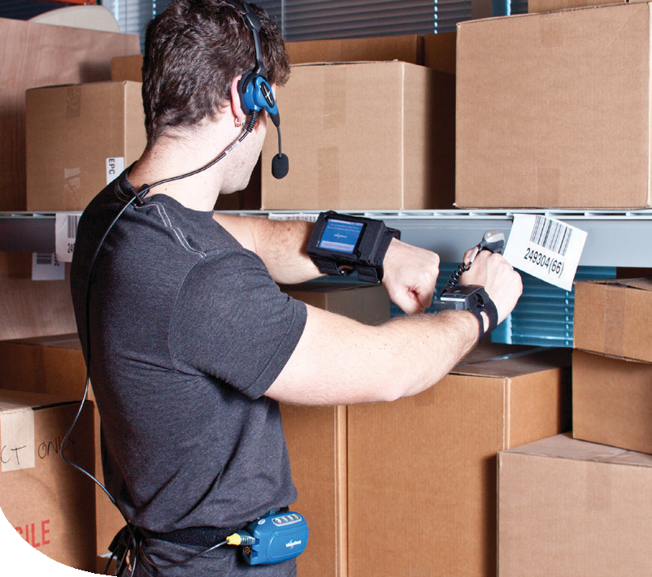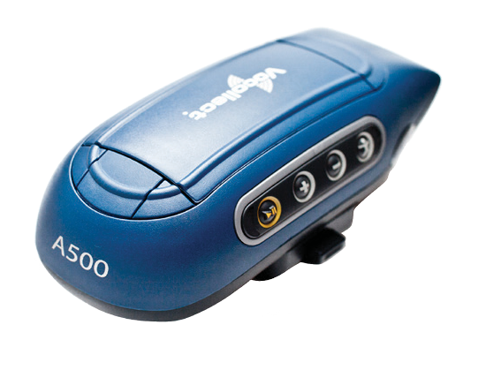

by Honeywell

Vocollect Talkman

A500

The Highest Performing

and Extensible Workflow Solution for Warehouses

The Vocollect Talkman® A500 is an extensible voice-centric mobile computing voice appliance that enables high-performance,

hands-free, and eyes-free workflows. It is the first Vocollect device to leverage the Next-Generation Vocollect Voice® software suite based on VoiceCatalyst®, making it the best solution to enable voice in all of your workflows throughout your distribution centre (DC) or warehouse.

The Talkman A500 running VoiceCatalyst offers the following benefits:

•

•

•

•

•

Supports many configurations from voice-only to voice combined with supplemental functions such as a scanner or display

Enables more dynamic interaction between enterprise systems and your mobile workers on the floor

Provides access to enhanced asset management and voice-centric usage statistics Offers a customisable user experience for mobile workers

Provides a simple migration path for current customers who want to get more out of their Vocollect Voice system

In addition, the Talkman A500 carries on the tradition of Vocollect’s voice solutions by enabling 10-20% gains in productivity and

greater than 99.99% accuracy across most DC workflows. It also provides industry-leading, industrial-grade speech recognition for high-speed productivity.

A Proven Solution with Expanded Capabilities

The Talkman A500 leverages the award-winning form factor of the Talkman T5, making it a proven, robust solution that is also one of the most technologically advanced mobile devices available that can withstand the harsh environments of warehouses. The expanded capabilities of the Talkman A500 enable current and new customers to use voice as the foundation for all of their

workflows in the DC. The Talkman A500 is the first Vocollect device

that customers can wirelessly connect to Bluetooth®-enabled display devices. As a result, customers can now voice-enable workflows that require mobile workers to occasionally reference long lists or images that may be best viewed on a display.

Compared to other Talkman devices, the A500 features:

•

•

•

A new, much more powerful processor

More flash and RAM

A more robust radio with expanded band capabilities

The Talkman A500 uses the same chargers, headsets and batteries as

the Talkman T5 series. It is also available with VoiceClient software to

use the same Tasks – easing side-by-side installations and extending

customers’ prior investments. Customers using the Talkman A500 today can easily migrate to the new VoiceCatalyst software

environment when needed to take advantage of the solution’s extended capabilities and workflows.

[voc_emea@vocollect.com](mailto:voc_emea@vocollect.com)

[www.vocollect.co.uk](http://www.vocollect.co.uk/)

**BUSINESS OPTIMISATION**

**SMART INNOVATION**

**OPERATIONAL FLEXIBILITY**

**PREMIER EXPERIENCE**

Features and Benefits of the A500

Extensible

•

•

One solution for multiple workflows, door to door

Support for multiple deployment options:

* Voice-only
* Voice plus scanning
* Voice plus display
* Voice plus mobile printing
* Voice plus combinations of scanning, mobile printing, and/or display

The Speed of Voice - Amplified

•

•

•

•

Up to 25% improvement in speech processing

Same battery as a Talkman T5, with longer life

Seamlessly switch from one workflow to another

Provides real-time critical information to your mobile workers, even as situations change

Wirelessly re-route your operations as needed, even mid-shift

•

Low Total Cost of Ownership

•

Compatible with scanners, mobile printers, and display

peripherals

Let workflow processes drive needed functionality so you only

add functions to supplement voice when it makes sense

Outfit your mobile workers just with the tools they need – don’t

burden them with unnecessary components

•

•

Put Vocollect Voice to Work for Your Mobile Workforce

Get ready for breakthrough productivity and profitability throughout your DC. For assistance with evaluating your choices in platforms, the cost/benefit trade-offs and performance options, contact Vocollect today!

About Vocollect

Vocollect is the leading provider of innovative voice technology solutions that help companies with mobile workers run a better business. Together with a global team of over 2,000 Vocollect Certified Professionals, Vocollect enables companies to save more than US$20 billion annually through further optimisation of operations, improving business decision capabilities and delivering

the industry’s premier worker experience in challenging industrial environments to nearly one million mobile workers who move in

excess of US$5 billion of products every day.

Vocollect integrates with all major WMS and ERP systems and supports the industry’s leading handheld computing devices. Visit us

[at www.vocollect.co.uk.](http://www.vocollect.co.uk/)

**Vocollect Global Contact Information**

**Region**

North America: EMEA:

Asia Pacific:

**Phone**

+1.412.829.8145

+44 (0) 1628 55 2900

Hong Kong: +852 3917 7000

China: +86 10 5957 2685

Australia: +61 409 527 201

**Email**

[info@vocollect.com](mailto:info@vocollect.com) [voc_emea@vocollect.com](mailto:voc_emea@vocollect.com)

[apac@vocollect.com](mailto:apac@vocollect.com)

**Region**

Latin America:

**Phone**

North: +52 55 5241 4800 ext 4915

South: +1.412.349.2477

+81 (0)3 3769 5601

Singapore: +65 6305 2369

India: +91 124480 6738

**Email**

[latin_america@vocollect.com](mailto:latin_america@vocollect.com)

Japan:

Singapore:

[japan@vocollect.com](mailto:japan@vocollect.com)

[singapore@vocollect.com](mailto:singapore@vocollect.com)

© Copyright 2013, Vocollect. All rights reserved. Vocollect, Vocollect Voice, Vocollect Enterprise Connectors, VoiceArtisan, VoiceApplications, VoiceCatalyst, VoiceExpress, VoiceLink, VoiceDirect, VoiceInterface Objects, and Hands-Free, Eyes-Free are either registered trademarks or trademarks of Vocollect.

Microsoft and Windows are either registered trademarks or trademarks of Microsoft Corporation in the United States and/or other countries. All other trademarks are property of their respective owners.

[voc_emea@vocollect.com](mailto:voc_emea@vocollect.com)

[www.vocollect.co.uk](http://www.vocollect.co.uk/)

**Vocollect Talkman® A500**

**Vocollect Voice**® **Software**

Voice Software

VoiceCatalyst® or VoiceClient®

Management Software

VoiceConsole®

Process Software

VoiceApplications™ or Tasks

Operating System

Microsoft® Windows CE 6

Processor

OMAP @ 500MHz

Memory

256MB RAM, 512MB Flash

Bluetooth®

Version 2.1

Radio

802.11a/b/g or 822.11b/g

Serial Ports

One

Operating Temperature

-30° to 50° C (-22° to 122° F)

Storage Temperature

-40° to 70° C (-40° to 158° F)

Drop Tested

Four drops from 5 feet on six

surfaces (24 drops). Two drops

from 6 feet on six surfaces (12

drops).

Battery

4400mAh

Humidity

100% Condensing

Rain/Dust Sealing Rating

IP67

**Accessory Support**

**Headsets**

Complete Vocollect® SR Series,

SRX, and SL-14

Peripherals

Scanners

Mobile Printers

Displays

**BUSINESS OPTIMISATION**

**SMART INNOVATION**

**OPERATIONAL FLEXIBILITY**

**PREMIER EXPERIENCE**