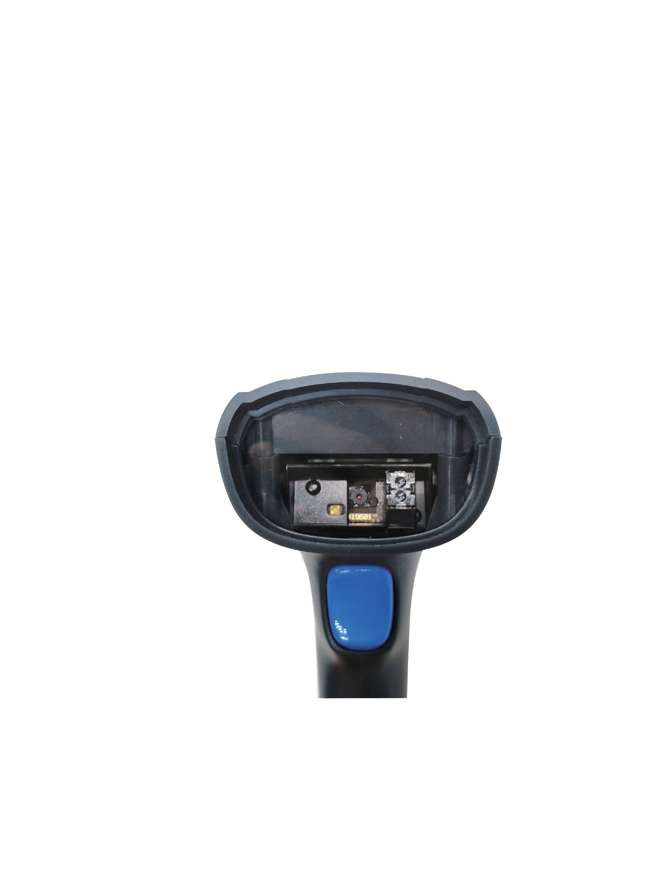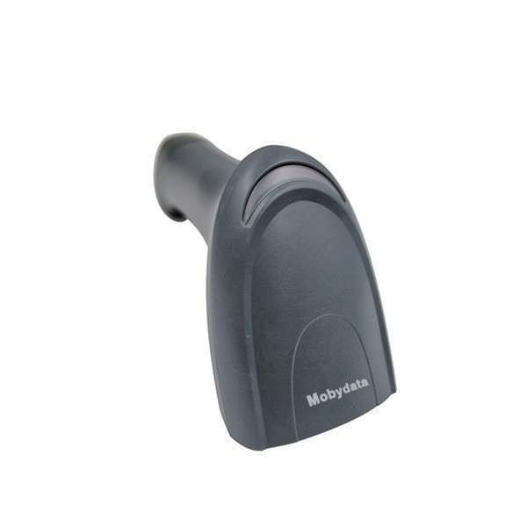

**KS1600**

二维影像扫描

2D imager scanner

**产品特点 Features**

善于读取长条码、褶皱条码、以及较大二维码

Good at reading long barcode,

wrinkled code, and big 2D code.

超宽视场角度FOV

Super wide FOV

善于读取屏幕条码

Good at screen code

最佳人机工程学

Best ergonomics

最佳读码指示提示，允许客户不需借助声音

Light indication instead of Voice

**行业应用 Applications**

零售业 Retail

轻工业 Light Industrial Application

物流快递 T&L

金融行业 Financial

医疗健康 Health Care

苏州摩比信通智能系统有限公司

86-512-68234699

[sales@mobydata.com](mailto:sales@mobydata.com)



**KS1600**

二维影像扫描

2D imager scanner

**Product Specification**

**Decoding Capability**

1D / LINEAR CODES

2D CODES

POSTAL CODES

Autodiscriminates all standard 1D codes including GS1 DataBar™ linear codes.

Aztec Code; Aztec Mesas; Data Matrix; MaxiCode; QR Code, Micro QR Code; China Han Xin Code Australian Post; British Post; Canadian Post; China Post; Japanese Post; IMB; KIX Post; Planet Code; Postnet; Royal Mail Code (RM4SCC)

EAN/JAN Composites; GS1 DataBar Composites; GS1 DataBar Expanded Stacked; GS1 DataBar Stacked; GS1

DataBar Stacked Omnidirectional; MacroPDF; MicroPDF417; PDF417; UPC A/E Composites

STACKED CODES

**READING PERFORMANCE**

IMAGER SENSOR LIGHT SOURCE MOTION TOLERANCE

PRINT CONTRAST RATIO (MINIMUM) READING ANGLE

READING INDICATORS RESOLUTION (MAXIMUM)

Field of View: 48 x 37º (H x V) Wide VGA: 640 x 480 pixels Aiming: 1 Blue LED; Illumination: White LED 350 - 770 nm 20 IPS

20%

Pitch: +/- 65°; Roll (Tilt): +/- 360°; Skew (Yaw): +/- 65°

Beeper (Adjustable Tone and Volume); Datalogic ‘Green Spot’ Good Read Feedback; Good Read LED Code 39: 4 mils: 0.102 mm PDF417: 6.6 mils: 0.168 mm QR/Data Matrix: 7.5 mils: 0.191 mm

**ELECTRICAL**

CURRENT INPUT VOLTAGE

Operating (Typical): 170 mA @ 5 VDC;Standby/Idle (Typical): 90 mA @ 5 VDC

5 VDC +/- 10%

**READING RANGES**

Minimum distance determined by symbol length and scan angle. Printing resolution, contrast, and ambient light dependent. Code 39: 5 mils: 0.5 to 12.5 cm / 0.2 to 4.9 in. EAN/UPCA: 13 mils: 0.5 to 30.0 cm / 0.2 to 11.8

in. PDF417: 6.6 mils: 1.0 to 9.5 cm / 0.4 to 3.7 in. Data Matrix: 10 mils: 1.0 to 9.5 cm / 0.4 to 3.7 in. QR: 20 mils:

1.0 to 14 cm / 0.4 to 5.5 in

TYPICAL DEPTH OF FIELD

**ENVIRONMENTAL**

AMBIENT LIGHT DROP RESISTANCE

ESD PROTECTION (AIR DISCHARGE) HUMIDITY (NON-CONDENSING) PARTICULATE AND WATER SEALING TEMPERATURE

Up to 92,000 lux

Withstands repeated drops from 1.5 m / 5.0 ft onto a concrete surface. 16 kV

0 - 95% IP42

Operating: 0 to 50 °C / 32 to 122 °F. Storage/Transport: -20 to 70 °C / -4 to 158 °F

**INTERFACES**

INTERFACES

KS1600R - RS-232/Keyboard Wedge; KS1600U -USB

**PHYSICAL CHARACTERISTICS**

DIMENSIONS DIMENSIONS

7.1 x 17.1 x 6.6 cm / 2.8 x 6.7 x 2.6 in

120.0g

**SAFETY & REGULATORY**

AGENCY APPROVALS ENVIRONMENTAL COMPLIANCE

The product meets necessary safety and regulatory approvals for its intended use. Complies to China RoHS; Complies to EU RoHS

**WARRANTY**

WARRANTY

1-Year Factory Warranty

苏州摩比信通智能系统有限公司

86-512-68234699

[sales@mobydata.com](mailto:sales@mobydata.com)